What is MLOps?
MLOps is a set of practices that combines machine learning, software engineering, and DevOps to manage the entire lifecycle of ML models—from development and training to deployment and monitoring in production.
- Integrates machine learning workflows with DevOps and data engineering practices
- Automates model training, deployment, monitoring and version control
- Improves collaboration, reproducibility and long-term model performance
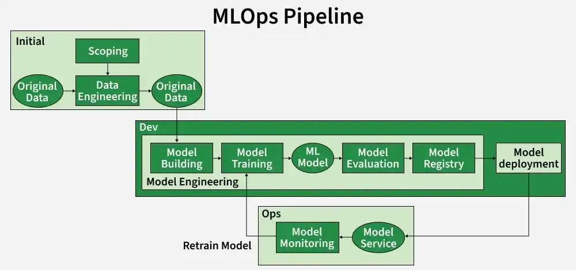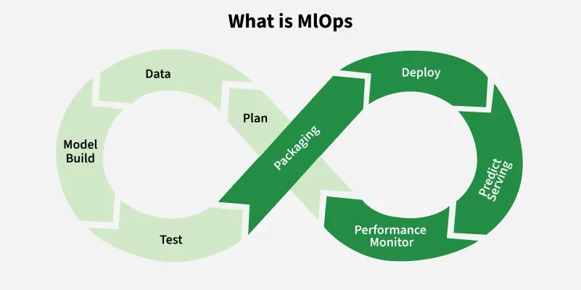
Why is MLOps Important

Imagine you build a model to predict house prices and it works well on your computer. But when you try to use it on a website problems arise like choosing the right model version, handling updated data, retraining regularly and checking performance. This is where MLOps helps. It ensures:
- All your work is well organized and versioned
- You can easily repeat model training and testing
- The model can be updated and used in real-world applications without extra effort
MLOps brings consistency, reliability and efficiency to machine learning workflows.
How to Implement MLOps
Implementing MLOps involves creating a structured workflow that ensures reproducible, reliable and scalable machine learning model development and deployment.
Step 1: Environment Setup
A standardized development environment ensures consistency and reproducibility across all stages of model development and deployment.
- Configure required software dependencies, libraries and frameworks.
- Document environments using tools like Conda, Docker or virtual environments.
- Enables seamless collaboration, onboarding and reproducibility across teams.
Step 2: Version Control
Version control is critical for managing code, datasets and model versions.
- Use Git for code and DVC or MLflow for data and model versioning.
- DVC creates a .dvc file with a unique hash, allowing you to return to any dataset version anytime.
- Track all changes for easy collaboration, debugging and auditability.
- Maintain a clear history of experiments and model iterations.
Step 3: Continuous Integration and Deployment (CI/CD)
CI/CD automates testing, integration and deployment to reduce human error and accelerate iteration.
- Use pipelines to test models, integrate changes and deploy automatically.
- Tools like Jenkins, GitHub Actions, GitLab CI/CD or ArgoCD help implement CI/CD.
- Ensures reliable, repeatable and fast deployments for production-ready models.
Step 4: Monitoring and Logging
Monitoring ensures models maintain performance, accuracy and reliability in production.
- Track model performance metrics (accuracy, precision, recall) and inference metrics (latency, throughput).
- Log inputs, outputs and errors for post-deployment analysis and debugging.
- Use tools like Prometheus, Grafana, ELK Stack or MLflow Tracking.
Step 5: Feedback Loop
A feedback loop enables continuous model improvement based on real-world performance.
- Incorporate user feedback, business metrics and domain expert input.
- Iteratively refine models to adapt to changing requirements and new data.
- Aligns model development with business goals and end-user needs.
Step 6: Model Tracking and Experiment Management
Tracking experiments and model versions ensures traceability and reproducibility.
- Use tools like MLflow, Weights and Biases or Neptune.ai for tracking experiments.
- Record hyperparameters, training data versions, evaluation metrics and model artifacts.
- Facilitates comparison across experiments and informed decision-making.
Step 7: Model Deployment
Deployment makes models accessible to users or downstream applications.
- Choose deployment strategies real-time APIs, batch processing or edge deployment.
- Use containerization (Docker/Kubernetes) and cloud platforms (AWS, GCP, Azure) for scalability and portability.
- Ensure security, access control and resource management for stable production environments.
Step 8: Scalability Planning
Plan infrastructure and workflows to handle increasing workloads and data volume.
- Optimize code and pipelines for efficient computation.
- Use scalable cloud resources and container orchestration for elastic resource management.
- Future-proofs your system against growing user demand.
Step 9: Security and Compliance
Secure data, models and infrastructure throughout the ML lifecycle.
- Implement encryption, authentication and access control.
- Audit third-party dependencies and maintain regulatory compliance.
- Protect against data leaks, model theft and unauthorized access.
Step 10: Data Storage and Management
Proper data handling ensures quality, consistency and reproducibility.
- Store datasets in object storage like S3, MinIO or GCS.
- Use DVC or similar tools to version datasets and track lineage.
- Ensure data integrity and easy rollback to previous versions.
Step 11: Automated Pipelines
Automate repetitive ML tasks to reduce manual intervention and errors.
Tools: Kubeflow Pipelines, Apache Airflow or Prefect.
- Design steps like data loading, preprocessing, training, testing and evaluation.
- Steps run automatically in the correct order and can be visualized in dashboards.
- You can modify parameters like model type or learning rate and compare results easily.
Step 12: Integration with GitOps
GitOps ensures end-to-end automation and traceability by connecting version control with deployment.
- Use GitHub Actions or ArgoCD to trigger pipeline execution on code or data changes.
- Ensures that updates are systematically tested and deployed without manual intervention.
Difference between MLOps and DevOps
Here we compare MLOps with DevOps:
Feature | MLOps | DevOps
Focus | Machine learning projects | Software development projects
Versioning | Tracks data, models and experiments | Tracks code versions data and models usually not included.
Components | ML models, data pipelines and feature engineering workflows. | Source code, binaries, configuration files and infrastructure as code.
Monitoring | Model performance, data drift, concept drift and ML-specific metrics. | Application performance, system metrics and user experience using traditional IT metrics.
Tools | ML frameworks,CI/CD tools and orchestration platforms | CI/CD and orchestration tools like Jenkins, GitLab CI/CD and Kubernetes.
Teams | Cross-functional data scientists, ML engineers, data engineers, DevOps | Developers, IT operations, QA and other software stakeholders
Update Frequency | Models are continuously retrained and updated based on new data and feedback. | Applications are updated based on release cycles or feature additions.
Advantages
MLOps helps make machine learning projects smoother and more reliable in many ways:
- Faster Model Training and Deployment: Automating tasks speeds up model training and put into use.
- Easier Experimentation: It becomes simple to try out different models and data to find what works best.
- Less Human Error: Automation reduces mistakes that can happen when tasks are done by hand.
- Repeatable and Trackable Steps: Every part of the process can be repeated and checked making it easier to understand and fix problems.
- Better Teamwork: Clear processes and shared tools help teams work together more smoothly.
Limitations
- Complex Setup: Setting up MLOps can be difficult and take a lot of time especially for beginners or small teams without much technical experience.
- High Costs: The tools and infrastructure needed for MLOps can be expensive making it harder for smaller projects to afford.
- Limited Flexibility: Some MLOps systems are not very flexible which can make it challenging to try new ideas or quickly change methods.
- Data Privacy and Security: Handling sensitive data in MLOps workflows requires extra care to protect privacy and keep information safe.
- Integration Challenges: Connecting MLOps with existing tools and processes can be complicated and may slow down early stages of development.

